**Software keylogger**

**A Project Report**

Submitted in partial fulfillment of the

Requirement for the award of the Degree of

**BACHELOR OF SCIENCE (INFORMATION TECHNOLOGY)**

**By**

**Prajwal Raju Adhav**

**221001**

**Under the esteemed guidance of**

**Mr. Amaresh Patra**

**Professor**



**DEPARTMENT OF INFORMATION TECHNOLOGY**

**VISHWESHWAR EDUCATION’S SOCIETY’S**

**WESTERN COLLAGE OF COMMERCE**

**&**

**BUSINESS MANAGEMENT**

***Affiliated to University of Mumbai***

**Plot No. 03, Sector. 09, Sanpada, Navi Mumbai 400705**

**2023-2024**

**VISHWESHWAR EDUCATION’S SOCIETY’S**

**WESTERN COLLAGE OF COMMERCE**

**&**

**BUSINESS MANAGEMENT**

***Affiliated to University of Mumbai***

**Plot No. 03, Sector. 09, Sanpada, Navi Mumbai 400705**



**CERTIFICATE**

This is to certify that the project entitled, “ **Software keylogger** ”,is bonafied work of **PRAJWAL RAJU ADHAV** bearing Seat.No: (**221001**) submitted in partial fulfillment of the requirements for the award of degree of BACHELOR OF SCIENCE in INFORMATION TECHNOLOGY from University of Mumbai.

**Internal Guide Coordinator External Examiner**

**Date: College Seal**

**ABSTRACT**

In many companies now-a-days data security and data recovery is the most important factor.

So there are many cases where data recovery is required. For these kinds of problems keylogger is one of the best solutions which is often referred to as keylogging or keyboard capturing.

Keyboard capturing is the action of recording the keys stroke on a keyboard, typically covertly, so that the person using the keyboard is unaware that their actions are being monitored. Using keylogger application users can retrieve data when working file is damaged due to several reasons like loss of power etc.

This is a surveillance application used to track the users which logs keystrokes; uses log files to retrieve information. Using this application we can recall forgotten email or URL. In this keylogger project, whenever the user types something through the keyboard, the keystrokes are captured and mailed to the mail id of admin without the knowledge of the user within the time set.

**ACKNOWLEDGEMENT**

To list who all have helped me is difficult because they are so numerous and the depth is so enormous. I would like to acknowledge the following as being idealistic channels and fresh dimensions in the completion of this project. I take this opportunity to thank the **University of Mumbai** for giving for giving me chance to do this project. I would like to thank my **Principal ,**

**DR. NITHYA VARGHESE** for providing the necessary facilities required for completion of this project.

I wish to express my profound and sincere gratitude to **HOD**

**Mrs. MEENAL PRADHAN**, who guided me into the intricacies of this project non-chalantly with matchless magnanimity. I thank **Mr. AMARESH PATRA** for extending their support during Course of this investigation. I would be failing in my duty if I don’t acknowledge the co-operation rendered during various stages of image interpretation by supervisor. I am highly grateful to supervisor who evinced keen interest and invaluable support in the progress and successful completion of my project work. I am indebted to my guides for their constant encouragement, co-operation and help. Words of gratitude are not enough to describe the accommodation and fortitude which they have shown throughout my endeavour.

I would like to thank my **COLLAGE LIBRARY**, for having provided various reference books and magazines related to my project. Lastly, I would like to thank each and every person who directly or indirectly helped me in the completion of the project especially **MYPARENTS AND PEERS** who supported me throughout my project.

**DECLARATION**

I hereby declare that the project entitled, “ **Software keylogger** ” done at **Western College of Commerce and Business Management**, has not been in any case duplicated to submit to any other university for the award of any degree. To the best of my knowledge other than me, no one has submitted to any other university.

The project is done in partial fulfillment of the requirements for the award of degree of **BACHELOR OF SCIENCE (INFORMATION TECHNOLOGY)** to be submitted as final semester project as part of our curriculum.

**Name and Signature of the Student**

**TABLE OF CONTENTS :-**

|  |  |  |  |
| --- | --- | --- | --- |
| **Sr. No.** | | **Title** | **Page No** |
| 1. | | Chapter 1: Introduction | 7 |
|  | 1.1 | Introduction | 8 |
|  | 1.2 | Aim and Objectives | 9 |
|  | 1.3 | Purpose and Scope | 10 |
|  | | 1.3.1 Purpose | 10 |
|  | | 1.3.2 Scope | 11 |
| 2. | | Chapter 2: System Analysis | 12 |
|  | 2.1 | Existing System | 13 |
|  | 2.2 | Proposed System | 13 |
|  | 2.3 | Requirement Analysis | 14 |
|  | 2.4 | Hardware Requirement | 14 |
|  | 2.5 | Software Requirement | 14 |
| 3. | | Chapter 3: System Design | 15 |
|  | 3.1 | System Module | 16 |
|  | 3.2 | Use Case Diagram | 17 |
|  | 3.3 | Flow Chart Diagram | 18 |

**CHAPTER 1**

* 1. **INTRODUCTION**

PROJECT NAME: SOFTWARE KEYLOGGER

In many IT infrastructure organizations now-a-days, data security and data recovery are the most important factors which is basically deployed in Computer Forensics. Computer forensics consists of the art of examining digital media to preserve, recover and analyze the data in an effective manner.

There are many cases where data recovery is required essentially. So by using keylogger application users can retrieve data in the time of disaster and damaging of working file due to loss of power etc. Keyloggers are specially effective in monitoring ongoing crimes.

This is a surveillance application used to track the users which log keystrokes, uses log files to retrieve information, capture a record of all typed keys. The collected information is saved on the system as a hidden file or emailed to the Admin or the forensic analyst.

In Today’s Era of Digitalization, Most of the Activities or Tasks are done through Internet. Even our day-to-day tasks have become so obsessed with internet to such a extent that mannier times it becomes difficult to survive without it.

To track what activities other do on pc we can make use of keyloggers, Often when it comes to keyloggers, everyone think that its illegal, Yaa its illegal but when we perform malicious activities such as stealing sensitive data, passwords, etc. There are many legal use of Keylogger in our day to day life . After all it depends upon the user how he is using .

But apart from this, keyloggers also serves various other purposes that can be used for benefit of parents and organizations. Through keylogger parents could be able to see how their child is accessing computer and managers could able to keep a watch on the activities done by employees on their allocated pc’s.

**1.2 AIM AND OBJECTIVE**

The aim why we are devoloping so that we can keep a track on our computing activities .

The Main objectives for using keyloggers are as follows:

* In the office, having a keylogger installed allows you to check on your employees and see how much time they actually spend working and how much time they spend doing stuff that’s not office-related. This’ll prevent employees from getting paid just to browse Facebook.
* At home, having keylogging software installed allows you to monitor your children’s activities and guide them accordingly.
* You can see whether or not they’ve really been working on that school project or they’ve simply been playing games or chatting with their friends.
* You can also protect your children from kidnappers or pedophiles since you can easily check whoever your children have been talking to online.
* Having keylogging software installed to spy on other peoples’ activity is usually an eye-opening experience, but surprisingly, some people have actually discovered that using the software on themselves allows them to stay productive.
* Since the first step to being productive is knowing how long it takes you to finish a task, installing the keylogging software will accurately record the times when you’re actually working and the times when you were just trying to convince yourself that you’re working.

**1.3 Purpose and Scope**

**1.3.1 Purpose**

The main objective of this document is to illustrate the requirements of the project Keylogger. Now-a-days IT business infrastructures are mostly in need of the cyber security factor that is Computer Forensics. Keyloggers can effectively assist a computer forensics analyst in the examination of digital media.

Keystroke loggers are available in software and hardware form, and are used to capture and compile a record of all typed keys. The information gathered from a keystroke logger can be saved on the system as a hidden file, or emailed to the forensic analyst or the Administrator. Generic keystroke loggers typically record the keystrokes associated with the keyboard typing. Advanced keystroke loggers have many additional features.

Our project keylogger has the following features;

• Monitors Keystrokes .

• Sends mail to the Admin’s mail Id .

• Logs keystrokes including special keys .

Keyloggers have the advantage of collecting information before it is encrypted; thus making a forensic analyst’s job easier. Most keyloggers show no signs of any intrusion within the system allowing for them to gain typed information without anyone having knowledge of its actions except the user who use it.

Keyloggers incorporate a wide array of cyber security issues and provide a practical approach to understand topics such as attacker goals, varieties of malware and their implementation, the role of malware in infecting and how stealth is archived in an infected system.

**1.3.2 Scope**

Keylogger is basically using keystroke logs to monitor the system and send the details to the admin through the mail server.

Keyloggerss provide the best solutions in case of such cases like; IT organizations can indicate their concerns by going after the culprit whose performance is deteriorating that of the whole organization, parents can maintain a check on their children’s activities, a particular person’s activities can be monitored, storing passwords of various social media profiles.

Above all, keylogger is one of the best implementation of fundamentals of ethical hacking. By using this some measures could be done accordingly that would save personal data from being in the hands of total strangers.

**CHAPTER 2**

**2.1** **EXISTING SYSTEMS**

A keylogger is been used all over world but it has Two types that are Hardware keylogger and Software keylogger . Hardware keylogger is been use in widely by Firms , Industires and etc. but software keylogger is not been use widely.

Software keylogger which are already available are use maximum for Unethical purpose and mostly used by the criminals and bad motive organisation which are harmful for us and for our society.

**2.2 PROPOSED SYSTEM**

In this new technologically enhanced world, some of them uses technology for right purposes whereas other uses it with Malicious intent. Organizations and even ordinary care for their confidentiality so Organization can make use keyloggers for monitoring purposes that even if some info was leaked through one of their employee, they will be able fetch the data through keylogger and catch the victim employee red handed.

Even parents make use of this with which they will be able to monitor their data as well as their children info what they are doing through pc. So that they can get to know if some malicious content they encounter they do necessary action so that their children will never perform this again

**2.3 Requirement Analysis**

The product will be operating in windows, Linux environment. The hardware configuration include Hard Disk: 40 GB, Monitor: 15” Color monitor, Keyboard: 122 keys. The basic input devices required are keyboard, mouse and output devices are monitor, mobile devices etc.

**2.4 HARDWARE REQUIREMENTS :**

1. Operating system : Windows and Linux specified
2. RAM : 512MB (minimum requirement)
3. Hard Disk : 1GB working space (minimum requirement)

**2.5 SOFTWARE REQUIREMENTS :**

1. pych arm (python Compiler)

* **Languages Used :**
  1. Frontend = Python , Java.
  2. Backend = CSS , JavaScript.
     1. CSS for designing.
     2. JavaScript for connecting Files.

**CHAPTER 3**

**3.1 System Module =**

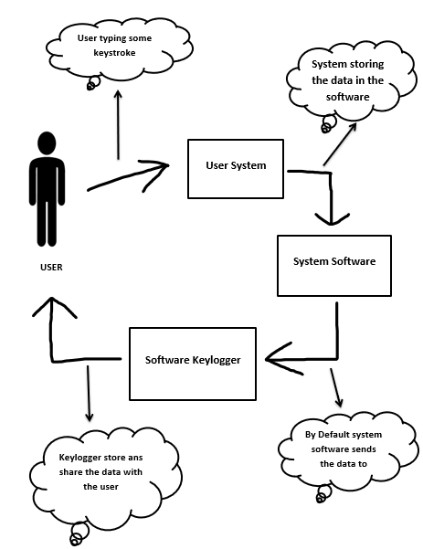

**Attributes :-**

1] Actor : In these actor is use to show user role in the software keylogger Flow .

2] Arrow : Arrow is use to show the direction and the work done during the direction from one entity to another entity .

3] Cloud Diagram : This diagram is use to show work done during the flow .

4] Use Case : Use Case is use to show the main components of the Software Keylogger flow .

**3.2 Use Case Diagram =**

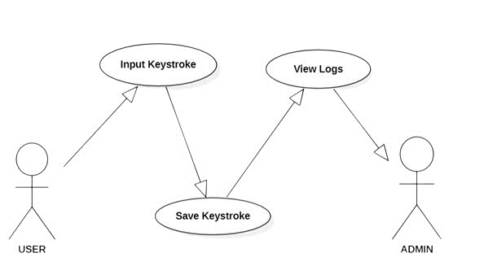

**Attributes :-**

1] Actor : Actor attribute is used show the role and responsbility of

“ **USER** ” and “ **ADMIN** ” in the Keylogger .

2] Use Case : Use Case diagram is used show the middle work of the Keylogger .

3] Arrow : Arrow is used to show the perfect Flow/Direction of the keylogger .

**3.3 Flow Chart Diagram =**

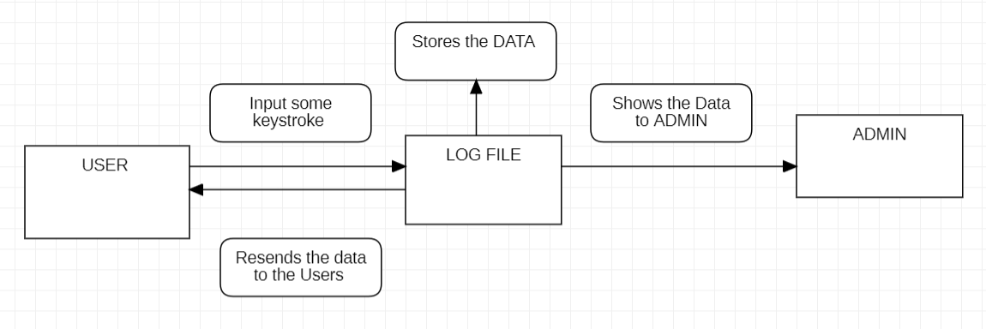

**Attributes :-**

1] Process : This attribute shows us that what are the process is going to take place and main component of the project.

2] Alternate Process : This attribute is used to show what are the alternate process going within the main component .

3] Flow arrow : This attribute is used to show the flow of the project between the components.

Link to complete the project :

<https://www.youtube.com/watch?v=25um032xgrw>

https://www.youtube.com/watch?v=B5rXhnjvavQ